Development Flow & Practice Plan Summary
This is my Week 1 deliverable for Module 1 (Introductory Meeting & Overview) of the ACLEDA Bank mobile development internship, which started on 28 September 2026. It summarises how mobile software is built in a banking environment and sets out how I will practise each day and week for the next 8 weeks.
Program element | How it works
Live trainer session | Mondays, 9:00 AM to 12:00 PM: concepts, demos and the week's project
Independent practice | Hands-on assignment during the week, at my own pace
Weekly submission | Work submitted at the end of each week for review, feedback and evaluation

Banking environment overview
In banking, a mobile app bug can mean lost money, exposed customer data or a regulatory breach, so security and compliance are built into every step rather than checked at the end. Three things set banking apps apart:
- Regulated: the bank answers to the central bank for how its technology is governed, secured and audited.
- High-value target: apps hold account data and move money, so they attract fraud, phishing and reverse-engineering.
- Trust-critical: customers expect the app to work every time or planned dowtime; any unexpected downtime and errors damage confidence in the bank itself.

Mobile development lifecycle and flow
Banking apps follow an iterative flow, and each stage has its own security and compliance gate, so issues are caught where they are cheapest to fix.
From my understanding:
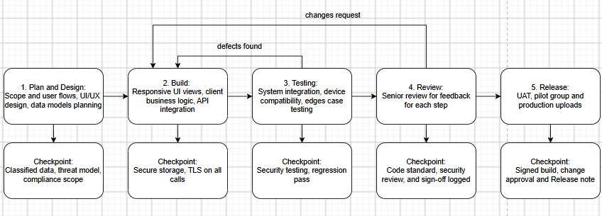Defects found in testing, and changes requested in review, loop back to the build stage for fixing and retesting. Only work that passes testing, senior review and its sign-off checklist is released.

ACLEDA's development workflow
At ACLEDA, a piece of work moves from requirement to production through these steps, with a senior code review before each move to the next environment:
- Requirement received: the business requirement is received and scoped.
- Development: the change is built.
- SIT: system integration testing of the developed change.
- Senior code review, then UAT: after review, the change moves to user acceptance testing.
- Senior code review, then Pilot: after review, it is released to a limited pilot group.
- Senior code review, then Production: after a final review, it is uploaded to production.
The repeated senior review is a quality gate: no change moves to UAT, pilot or production without a second person checking the code. The pilot step limits risk by trying the release with a small group before all customers receive it.

SDLC stages
The Software Development Life Cycle (SDLC) is the standard sequence of stages software moves through from idea to retirement. Each stage has defined outputs and checks, which makes work planned, traceable and tested before it reaches customers.
Stage | What happens | Output | Banking focus | ACLEDA Process
1. Planning | Decide what to build and why; estimate cost, time and risk | Approved request or project scope | Business and risk approval before work starts | Requirement Received
2. Requirements | Capture what the software must do and how well (security, performance, compliance) | Requirements document or user stories | Regulatory and data protection requirements recorded | Requirement Received
3. Design | Plan architecture, screens, data models and APIs | Design documents, UI mockups | Encryption, access control and data flows designed in | Development
4. Development | Write code on branches, with peer review before merging | Working code in the repository | Secure coding, no hardcoded secrets | Development
5. Testing | Unit tests, SIT, UAT, security and regression testing | Test results, bug log | Evidence kept for audit | SIT (staging), then UAT
6. Deployment | Package the release, get sign-off, deploy or submit to app stores | Live release | Change approval and segregation of duties | Pilot, then Production, each after senior code review
7. Maintenance | Monitor, fix bugs, patch security issues, add improvements | Updates that re-enter the cycle | Incident response and timely security patches | To confirm

Types of testing in stage 5
- Unit testing: checks individual functions in isolation.
- SIT (System Integration Testing): checks the app works with other systems such as core banking and APIs.
- UAT (User Acceptance Testing): business users confirm it meets their needs.
- Security testing: looks for vulnerabilities, using checklists such as OWASP MASVS.
- Regression testing: confirms nothing that already worked has broken.

Common SDLC models
- Waterfall: each stage happens once, in strict order; predictable but slow to change.
- Agile: the cycle repeats in short sprints, often 2 weeks, delivering small pieces frequently.
- V-Model: each build stage is paired with a matching test stage; common where verification matters.
Banks often use a hybrid: agile-style development combined with strict gates for testing, security review and change approval before anything reaches production.

What makes SDLC in banking different
- Change control: every production change needs documented approval.
- Segregation of duties: the person who writes the code is not the one who approves or deploys it, which is why ACLEDA's flow includes a senior review.
- Audit trail: tickets, commits, test results and approvals are kept as evidence for regulators such as the National Bank of Cambodia.
- Security at every stage: controls are designed in from planning, not added at the end.

Standard and rules of Mobile Development
Standard | Issued by | What it covers | What it means for my code
Technology Risk Management Guidelines (2019) | National Bank of Cambodia | IT governance, information security, third-party risk, data privacy and integrity, compliance and reporting for all banks in Cambodia | Follow the bank's secure development, change control and access rules; changes are reviewed and traceable
OWASP MASVS | OWASP | Industry baseline for mobile app security: storage, cryptography, authentication, network, platform, code quality, resilience, privacy | My checklist for Modules 4 to 7: secure storage, encrypted traffic, safe logging, no hardcoded secrets
OWASP Mobile Top 10 | OWASP | The most common mobile app risks | Quick reference when reviewing my own and peers' code
Draft Law on Personal Data Protection | Cambodia, Ministry of Posts and Telecommunications | GDPR-style rules on collecting and processing personal data; still a draft, not yet enacted | Collect only the data a feature needs, and never log or expose personal data

Sources
- NBC Technology Risk Management Guidelines, July 2019
- NBC guideline scope summary (ARCON)
- OWASP MASVS
- Data protection in Cambodia (DLA Piper)

